

OGWENO E | LAV project | March 16, 2022

AIRFRAME BUILD REPORT

8TH march 2022

# **Objectives**

The following were the objectives of the practical carried out:

1. To fabricate the wing sections and analyze their structural integrity.
2. To fabricate the airframe and perform load testing.
3. To test the performance of the BLDC motors.

# **Materials**

* Two forex boards [density=?]
* 2 A2-sized printings of the airfoil wing sections
* 1 BLDC motor, and ESC and a power converter.
* Umbrella aluminum wires.

# **Methodology**

[JKUAT, iPIC]

* The A2 papers were glued to the forex board and the airfoil wing sections cut out using a power saw cutting machine.
* Finishing was done on them using various grade sand papers.
* Using a hand-held drill, holes were made on the sections to allow for passage of the aluminum wires.

# **Results and Insights**

The power saw proved quite accurate in getting the general shapes of the airfoils which were then smoothed to their exact outlines using sandpapers. The following airfoil wing sections were produced. 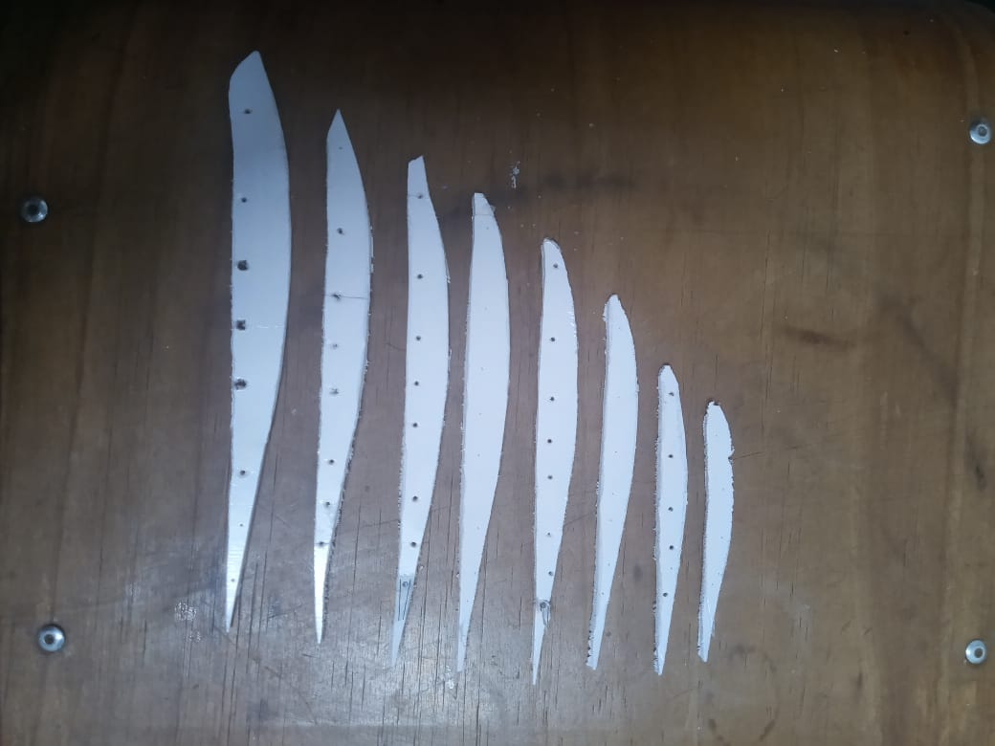

The airfoil sections however turned out to be of very small size and the material was also too weak and occasionally snapped. This snapping was further aggravated when we tried to enlarge the holes meant for passing of the aluminum connecting wires.

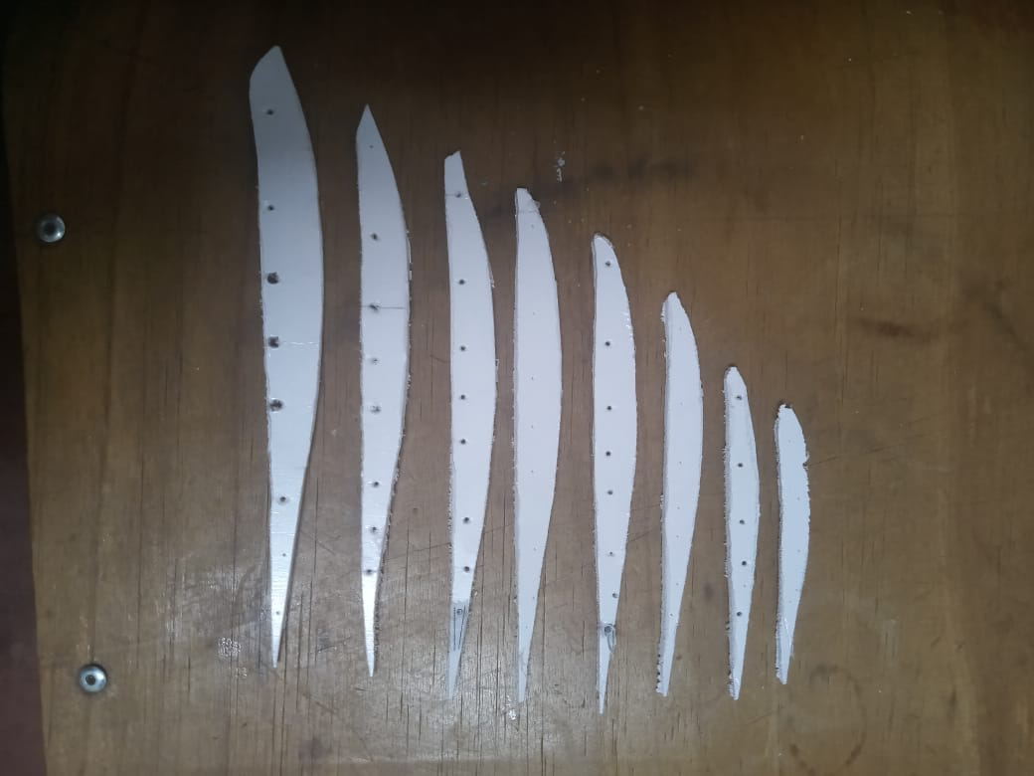

Due to the very weak nature and small size of the wing sections it was impossible to fabricate the entire airframe as any attempt to connect the sections using aluminum only led to further snapping. These were the main conclusions of the test:

1. ***Forex board was not a suitable material and alternative material was to be researched.***
2. ***The size of the vehicle was relatively small and suggestions were made to increase the span to about 1 m to allow for larger sections and space for the electronic equipment.***
3. ***The umbrella aluminum wires were also not desired and research into better material that improved structural integrity of the vehicle was advised.***

Due to time constraints and unavailability of most of the power and electronics members, it was not possible to perform performance test on the motor. This was postponed to a later date.